NAME: S.ajay Kumar reddy

REG. NO.: 192211480

Experiment: 15

AIM

Data Link Layer Traffic Simulation using Packet Tracer Analysis of CSMA/CD & CSMA/CA

REQUIREMENTS:

1. End device - They are the devices through which we can pass message from one device to another and they are interconnected.

2. Switch/Hub - Interface Between two devices.

3. Cable - Used to connect two devices

Procedure:

STEP 1: Click on end devices, select generic Pc’s drag and drop it on the

window. Click on SWITCH drag and drop it on the window.

STEP 2: Select the straight through cable and connect all end device to switch. Assign the IP address for all end devices. (Double click the end device Select →

desktop → IP configuration static)

STEP 3: Now set the IP address to Host A (192.168.1.1) in static mode. Similarly set IP address for Host B (192.168.1.2) and Host C (192.168.1.3)

STEP 5: To view the IP address, give ipconfig command in command prompt. Using ping command, we can establish communication between two host devices.

STEP 6: Now display the packet transmission in simulation mode.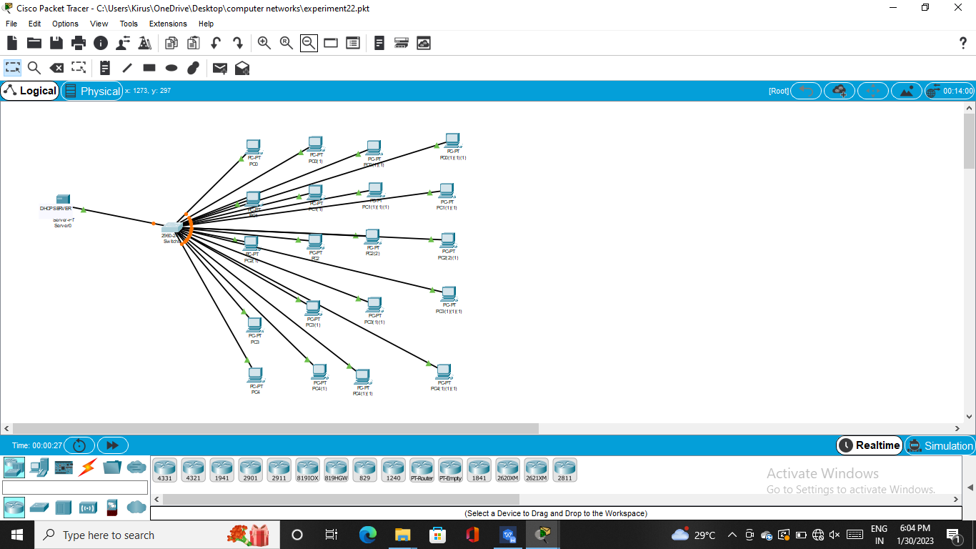

RESULT

the configuration of data Link Layer Traffic Simulation using Packet Tracer Analysis of CSMA/CD & CSMA/CA